Use for time stamp, Use:
50 min when done recent
19hrs when done recent
Yesterday 18hrs
Month day when done this year
Month day, year when post are done last year

Notice the alert icons spread out evenly and the their size,
Notice the thumbnail and Fname, setting and logout spread out name and evenly
Notice the height of blue bar
Notice the progress bar under the blue bar
Notice the gray space is evenly enclosing all the columns
Notice the add friend is wide to handle long names
Norice the case for member name next to Logined as
Notice the Write Comment shap
Notice the write comment needs to be included after each post
Notice the follow of the comment for each post
Please Update the left navigation according to the document
Please make sure the user name is showing the full name when when posting
please note the when selecting the post setting, it jump to the top of the page.
Please note the Hide post is not working after refreshing.
Please allow to see who like a post not just the counter when highting the LIKE
Please allow for more than one image addition in any post.
Please pay attenation the way the image is loaded in any post see FB.

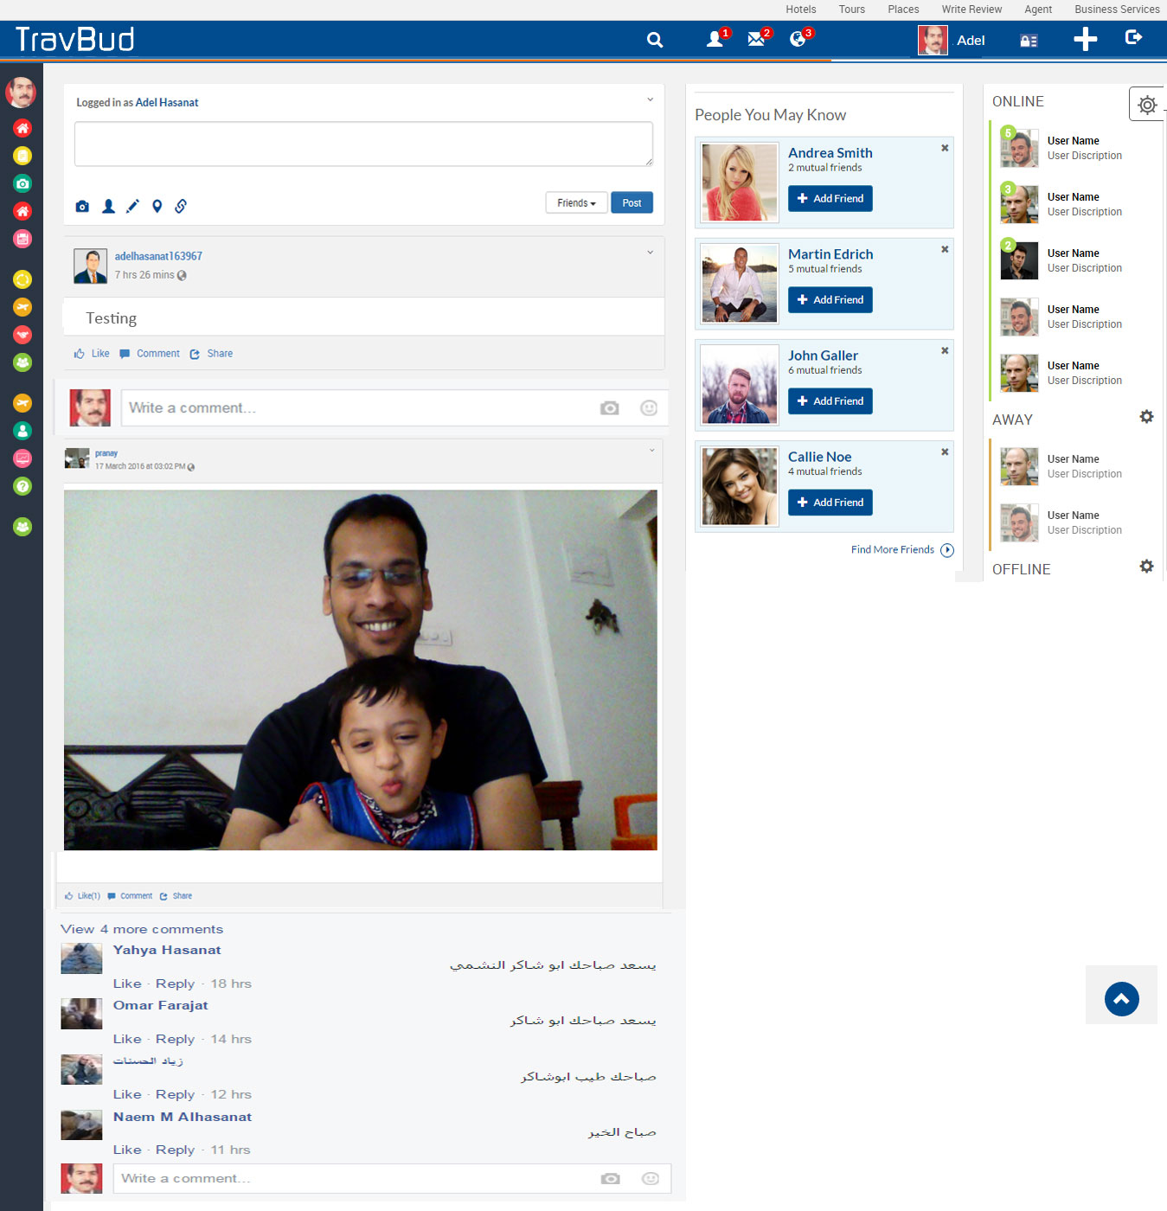

Notice the way we handle the security setting per item as the set value shows even if it is not in the edit mode
Notice we need to have each title on one row
Notice the setting for the Privacy and Blocking that is attached from FB

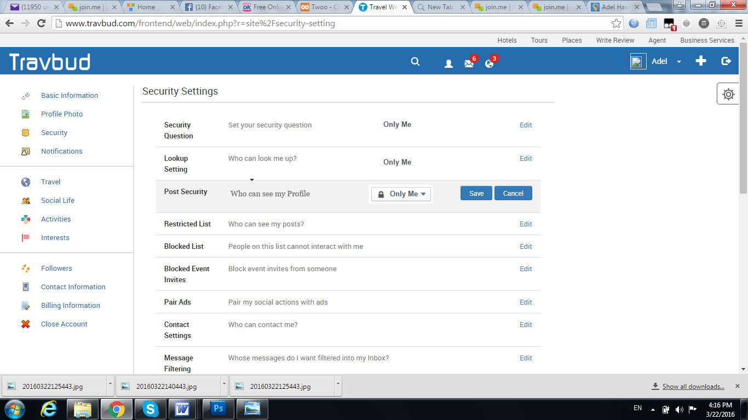

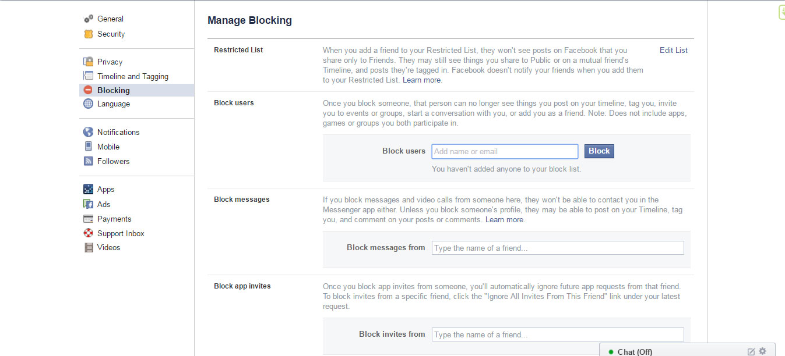

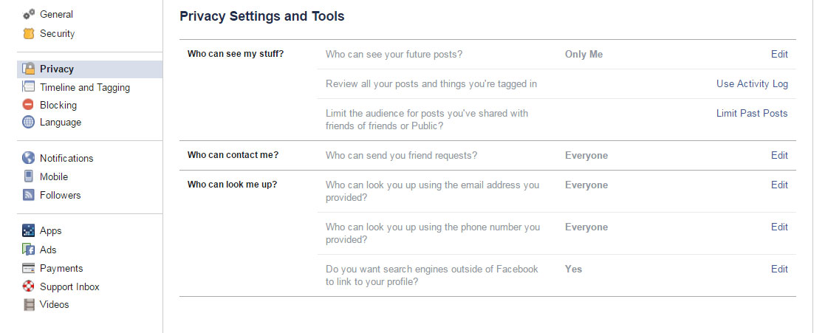

Notice the On/Off setting for the Notifications
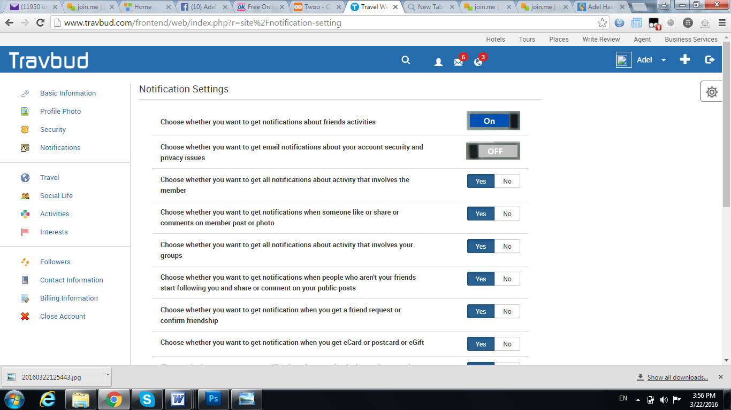

Please note how to handle the birdate

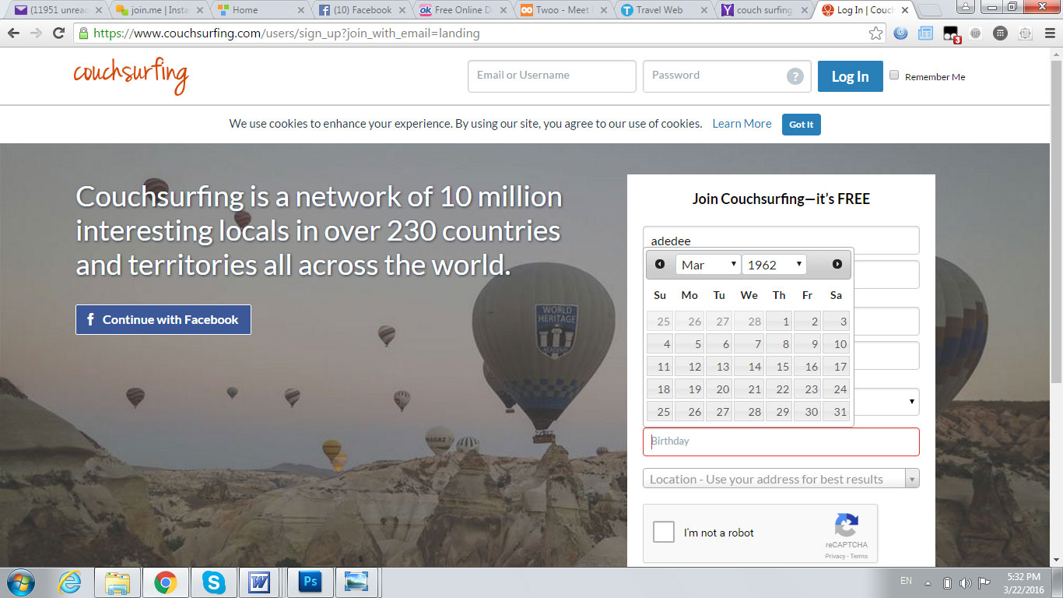

Please note how we handle the city and country search
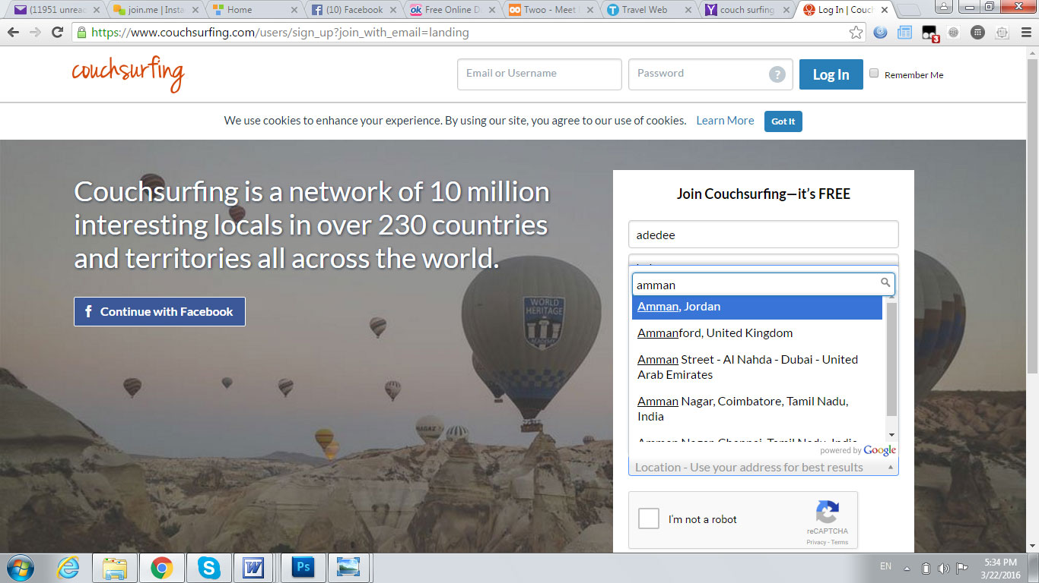

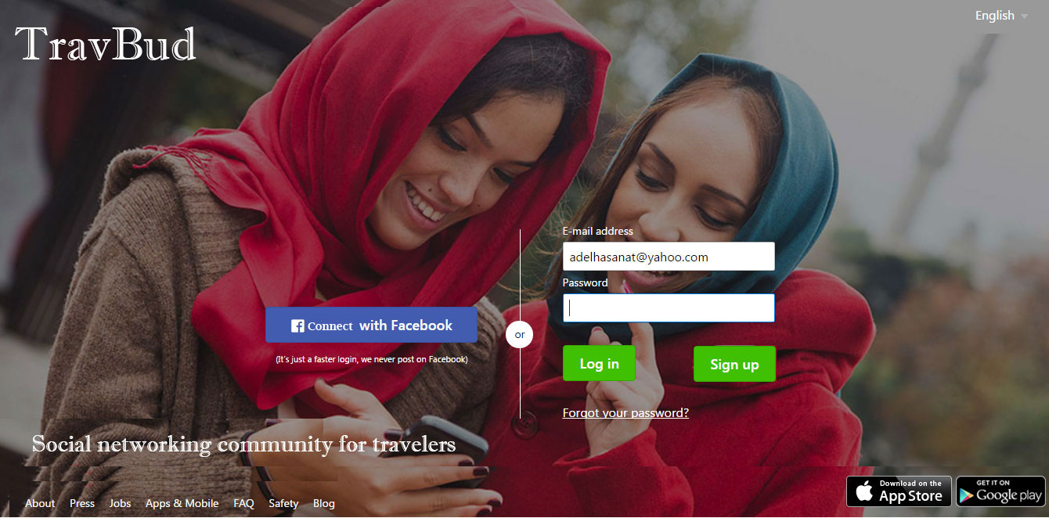

Please note the X to allow the member to close the screen if want to back to previous page, Aslo we can use this for forget pass

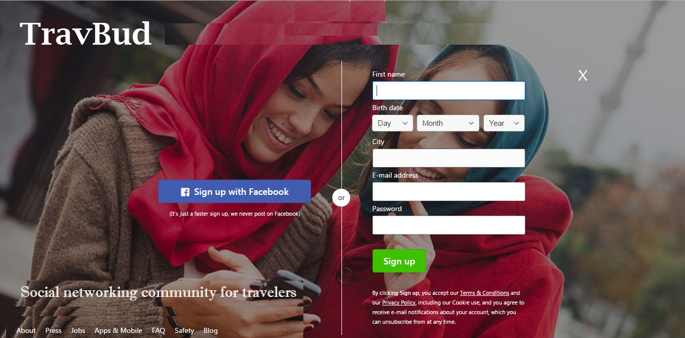

Please Note to have the field Name is bold, we need to use darker color than the field text but we need to use the same color throughout the website to maintain consistey.
Notice the gray shade around the fields box.
Notice the progress timing that hold more information about the section.
Please include the green check when the field is filled correctly and include a red X when is not filled correctly.
Allow member to set privacy for birthdate and Mobil num
For the Caption use big letter or better we may do another mean by adding two numbers and allow the member to put the value in the box
For example you may say “Add 3 and 2” and the member put “5” in the check box and that is good to verify that not a spam.

Use Create Account icon when the member is done
Pre set the Mobil num with the country code
Now for the city we may use the approach I suggested earlier or we may use the approach in the profile page put we need to have it done automatically some what.
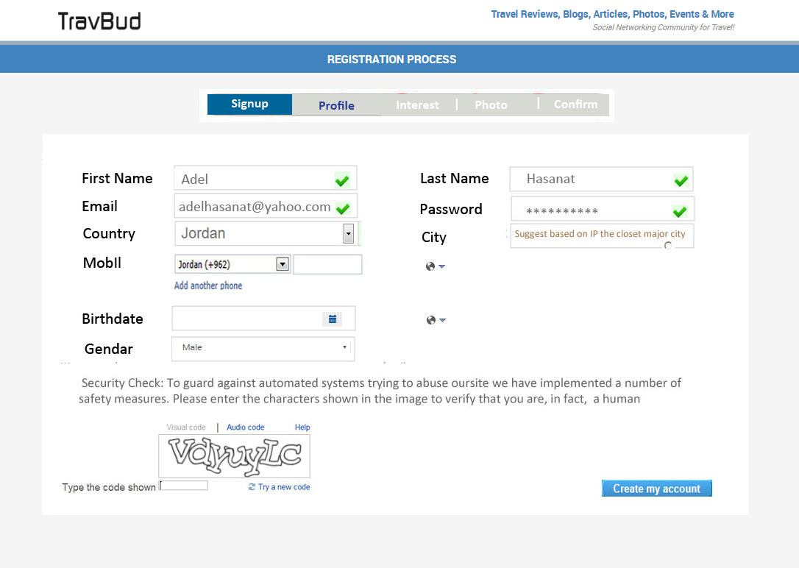

This the 2nd page in the registration process
We need to use selection as much as possible to allow for more easy way to fill the box
For example education, we may list the conmen degrees and high school listing for the user to choose from
For Occupations also we may list job allowing the member to choose from
For the languages also we can do a list
For interest we have to do check box kind of setup that allows the member to choose more that one item.
Please follow the design shown below for the hosting part

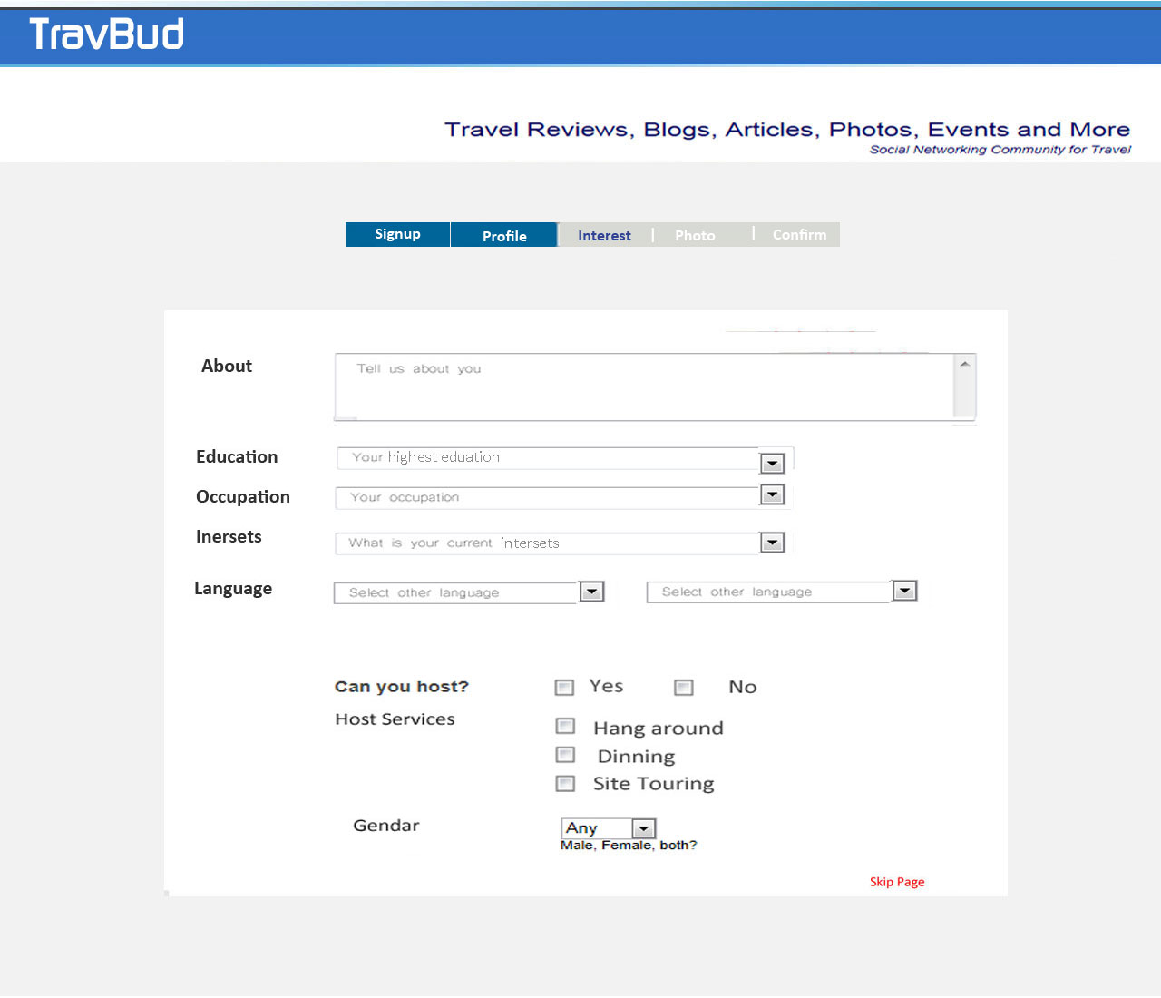

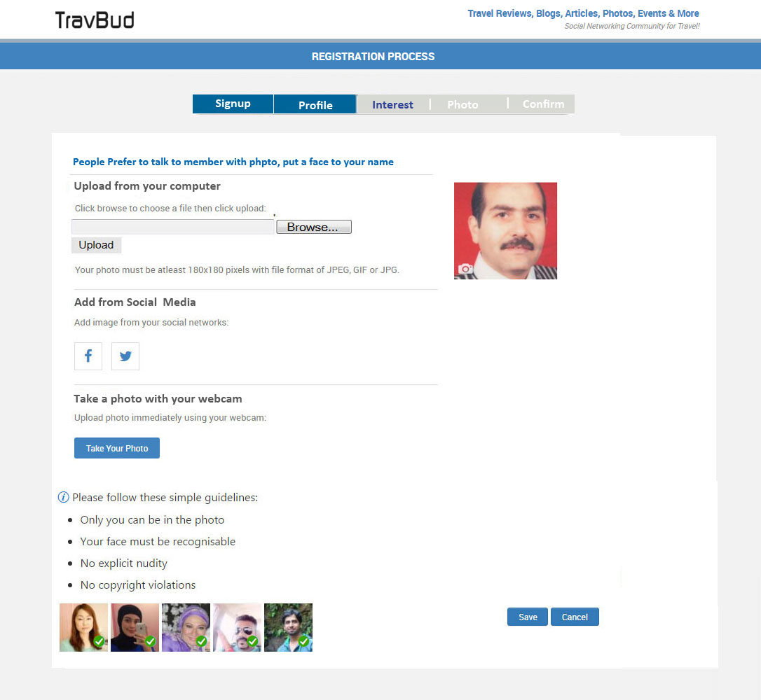

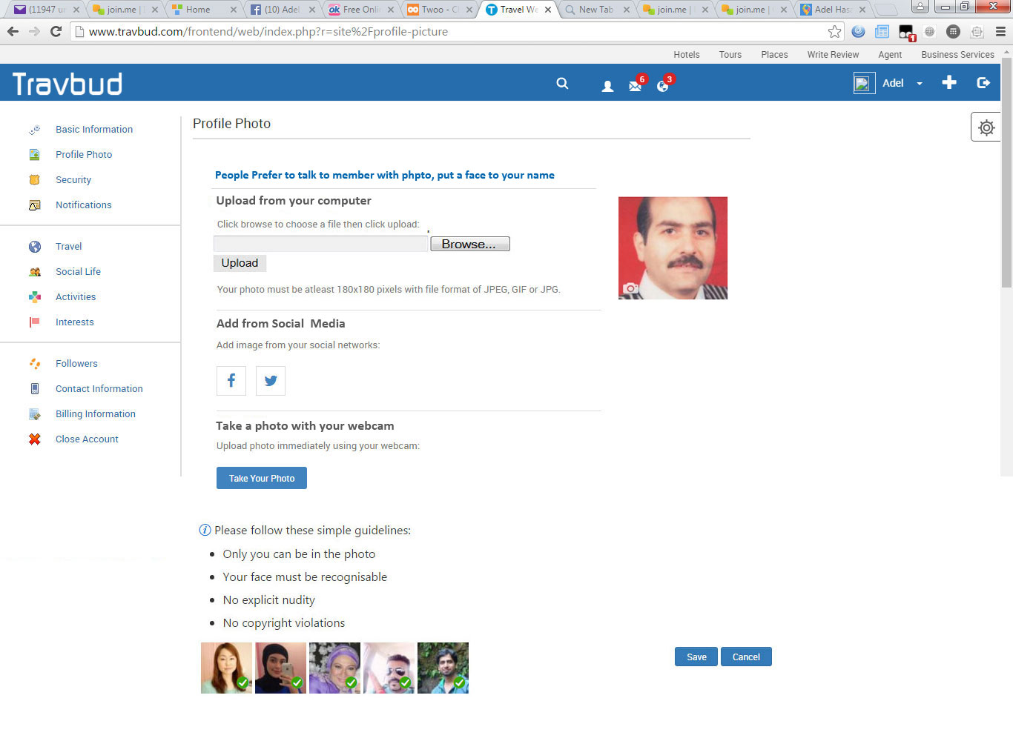
Please note the that 3 columns will look better and different from FB
Please note the look of the photo, gallery, post, saved and wall Graphic Design look you may check Wayn.com
Please use the gray shadow level as shown in the image
Please use more bold and bigger font for the photo, friend …. As shown in the image
Please bay attention to divide the 3 columns by the gray shadow evenly
